mimio matters

A quick reference for teachers and students, which includes:
- mimio Notebook
- mimio Tools
- mimio Gallery

By:
Ashley Martin mart6740@fredonia.edu
Jennifer Burr burr0996@fredonia.edu
Sarah Taylor tayl0435@fredonia.edu
mimio matters

What is mimio?

mimio is an interactive technology that is used to transform ordinary white boards into interactive ones, it is a great tool that can be used to increase student participation in the classroom. A major advantage to using mimio is that it is very helpful when students are learning new material since notes can be printed to assist students with IEPs, emailed to absent students, posted on the internet so they are easily accessible to students and parents, and copied and pasted so that they can be incorporated into other applications. Although, the main advantage of using mimio is that teachers can distribute and archive class notes while students focus on understanding the lesson being presented as opposed to copying the board.

For more information on mimio please refer to:
http://www.mimio.com/index.asp
What is needed to make your mimio come to life?

- white board
- mimio bar
- Mac, Linux, or Windows computer
- LCD projector
Here is a brief start to exploring mimio:
So first, let’s focus on:
- mimio Notebook
- mimio Tools
- mimio Gallery

mimio Notebook
To open mimio Notebook with Microsoft Windows, double click on the mimio Notebook icon on your desktop, which will open a new page. To open mimio Notebook with Macintosh, click on the icon permanently affixed on your dock. To open mimio Notebook with Linux click on mimio studio in the application menu and then click on mimio notebook.
You can create and present information within mimio Notebook. Content created in mimio Notebook can be saved as mimio .ink files as well as .html, .jpeg, .png, .gif, .bmp, .tif, .pdf.

To view the information within mimio Notebook you can use the view for one page at a time by clicking on the single page view. To view a few to all of the information at a time you can switch to multi page view. All of these options are on the left hand side of the mimio Notebook application.

To delete pages in mimio Notebook application, in multi page view, select the pages you wish to delete. Next, on the menu at the top of the application, click on Edit/Delete or you can use the Delete icon from the mimio Notebook menu.

.doc, .ppt, and .pdf files can be directly imported into mimio Notebook as an image on a separate mimio Notebook page. Macintosh will allow imports of Excel files, but Linux will not.

To import, you can do one of following:

- Click on File then Import
- Click on your desired file and press Open.
- On the bottom left corner of mimio Notebook, the words “Loading Document” will appear until the file is imported into mimio Notebook.

OR

- 2. Click and drag the file icon into mimio Notebook.
- On the bottom left corner of mimio Notebook, the words “Loading Document” will appear until the file is imported into mimio Notebook.

To save work within mimio Notebook, go to the top menu and click on File, and then Save As. Choose the name, location, and file format (.ink, .html, .jpg, .bmp, .png, .tif, .pdf) for Windows. Macintosh will allow files to be saved as the above Windows formats, as well as .jp2, .pict, .psd, and .sgi. Linux will only allow you to save files as .ink, .html, .jpeg, .png, .bmp, .tif, and cur. Once you have selected your file format, click Save.

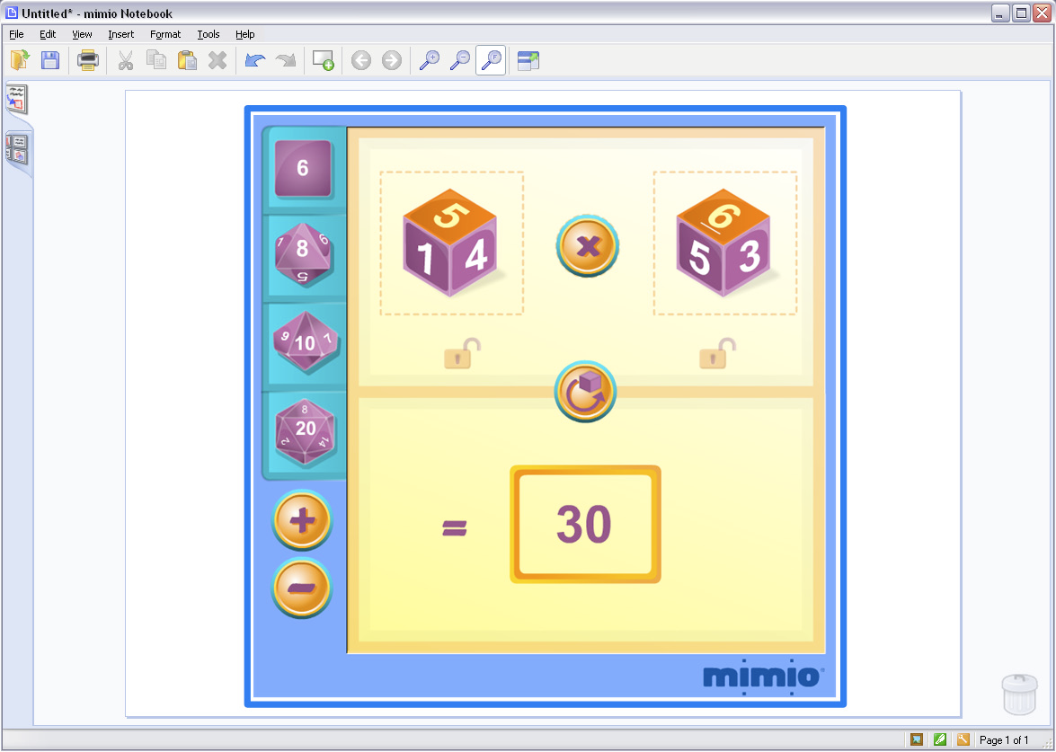

mimio Tools
The mimio Toolbar should open along with mimio Notebook. If it doesn’t open or you
closed it by mistake, click on Tools then mimio Tools. You can also double-click on the green tools icon in the bottom right-hand corner of mimio Notebook.
To use the Pen or Highlighter feature, use the color/transparency preview section to preview the color of the pen. Then, you can use the color section to choose from the eight quick colors. It is possible to use the color palette icon to choose more than eight colors. To change the widths of the pen or highlighter, use the line thickness section.
To erase the pen marks or highlighter marks, the eraser icon can be used to erase pen and highlighter. Again, using the line thickness section you can change the width of the eraser, which may be helpful.
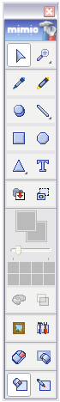
mimio Gallery
The layout of the Gallery contains four subareas. These four subareas include Images (includes pictures), Templates (includes .ink files), Multimedia (includes audio and video files), and Lessons (includes mimio .ink lessons).
To search within the Gallery, use the keyword Search at the top of the Gallery window. Click to highlight the folder in which you choose to search. To continue a specific search, expand the main Gallery folders to view subfolders, the content will automatically be sorted when you view the folders.
