Ashley Martin mart6740@fredonia.edu Kristen Wall wall7230@fredonia.edu
Robert Rappole rapp0384@fredonia.edu Robert Longtin long4153@fredonia.edu

Introduction:
To participate in this activity you will have to use your math skills to discover the secret behind four card tricks that are like no others. You will be shown the card tricks multiple times, and the first person to discover the secret to each trick will win a prize. By the end of the activity you will have amazing tricks to take with you to perform for all of your family and friends, and not only will you be able to impress them with your ability to perform the tricks, but you will also be able to shock and amaze them with your amazing math skills. So…who will discover the secret to each trick first?

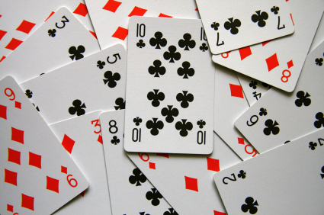

Materials Needed:
- Deck of Cards
- Prizes!
- Your Brain!
Procedure:
- We will first begin by splitting all of the participants up into four groups, each group designated to an expert “Mathemagician”.
- Then each Mathemagician will demonstrate a card trick several times for the participants, each one given ample time to discover the secret behind how the trick works.
- The first participant who is able to discover the secret behind one of the card tricks will receive a prize. There will be four possible winners for each rotation throughout the night. Each winner may only receive one prize-that way other participants have a chance to win a prize and discover the secrets to the tricks as well.
- When the participants have either discovered the secrets or are stuck on the answers, the Mathemagicians will reveal the processes behind the tricks.
- An explanation of why these tricks work will also be provided as each step is explained, so that you can reproduce the tricks with your friends and sound highly intelligent at the same time!

Hint: Try completing the following questions before coming to see our Magic Show!
- How many cards are there in a standard deck?

- How many cards are there in each suit?

- How many different cards are there in a particular color?

- If you arrange 52 cards into piles of no more than 13 cards, what is the minimum number of piles of cards that you can have?

- What is the pattern in the following group of numbers (2,4,6,8,10)?

- What is the pattern in the following group of numbers (0,4,8,12,16,20,24)?

- If we were to pick a card at random from the deck, what is the chance of it being an ace? How do you know?

- If we were to pick a card at random what are the chances of it being a red card? How do you know?

