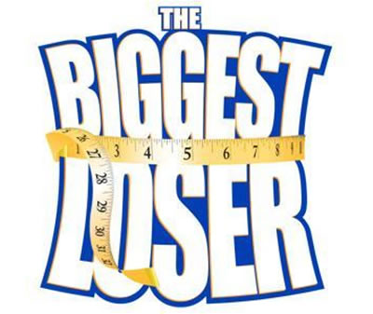
Introduction:
This is an exciting game which requires teams to calculate percent decrease quickly and accurately. Teams compete to move around the board the fastest. The biggest loser wins!
Materials Needed:
- Large foam dice
- Life-sized game board
- Pencil and paper
- Prizes
- Various props for physical challenges
Directions and Rules:
- Teams work together to calculate percent decrease problems in a specified time frame.
- If the calculation is correct, the team rolls a die and one player moves along the game board. Some spots on the board have specific instructions which need to be followed.
- Each round, the teammates take turns moving around the board. This procedure is repeated until time runs out. Whichever team has moved the farthest around the board is the biggest loser…or winner.

Sample Problems

Use the following equation to solve these problems:

$$percent decrease=\frac{beginning value-ending value}{beginning value}$$

- Beginning value = 2, Ending value = 1

- Beginning value = 4, Ending value = 3

- Beginning value = 8,Ending value = 5

- Beginning value = 20, Ending value = 15

- Beginning value = 5, Ending value = 7

*A bonus roll would be awarded on such a question for recognizing a negative decrease as an increase.
Answer Key:
- $\frac{\left(2-1\right)}{2}=\frac{1}{2}=50\%$
- $\frac{4-3}{3}=\frac{1}{4}=25\%$
- $\frac{8-5}{8}=\frac{3}{8}=37.5\%$
- $\frac{20-15}{20}=\frac{5}{20}=25\%$
- $\frac{5-7}{5}=-\frac{2}{5}=-40\%$

