Jamie Bish
Michael Humbert
MAED 419
Methods for Teaching Secondary Mathematics

Logical Problem Solving

Introduction:
Critical thinking ability forms the foundation of a good mathematical proof. This lesson is designed to encourage the development and growth of critical thinking skills through the use of logic puzzles. It is intended for high school students as an introduction to writing proofs.

Standards:
From the NYS core curriculum guide students should be able to do the following:
A.PS.2 Recognize and understand equivalent representations of a
problem situation or a mathematical concept
A.RP.5 Construct logical arguments that verify claims or
counterexamples that refute them
A.RP.11 Use a Venn diagram to support a logical argument
A.CM.5 Communicate logical arguments clearly, showing why a result
makes sense and why the reasoning is valid
A.RP.1 Recognize that mathematical ideas can be supported by a
variety of strategies

Objectives:
At the lesson’s conclusion the students should be able to:
- Understand the meaning of arguments and statements and articulate what they mean.
- Construct valid and fallacious arguments, evaluate them, and explain why they are valid or fallacious.
- Identify and explain different kinds of inferential relationships and patterns.
- Use the underlying principles of argument structure to analyze and represent a problem.
- Apply general logical principles to the context of a subject matter.

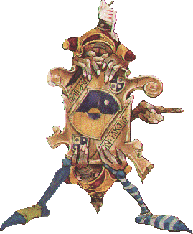 | The Tale of Two Doors | 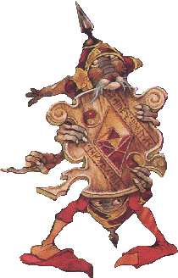

Labyrinth is a 1986 fantasy film directed by Jim Henson (creator of the Muppets) and produced by George Lucas. The plot revolves around a young girl Sarah and her quest to rescue her little brother from the Goblin King while trapped in an enormous labyrinth full puzzles and riddles to slow her down. One such puzzle involves her run-in with four guards...

<Scene from Labyrinth>

Sarah has a choice to make. One door leads to certain death and one door leads to the castle. But in front of each door there is a guard; one whom always lies and one whom always tells the truth. You can ask just one question.

(Answer in Wrap Up)

A Little History

These are the types of problems which have been at the heart of logic for centuries. Logic evolved originally from the Greek school of philosophy. Certainly other civilizations understood a great deal about mathematics and specifically geometry. For instance the ancient Egyptians even understood the Pythagorean Theorem centuries before Pythagoras had been born. However, the mathematical ideas during this time were very “recipe like” and it wasn’t until the time of the ancient Greeks in about 6th century BC that mathematicians attempted to rigorously prove these claims.

Pythagoras
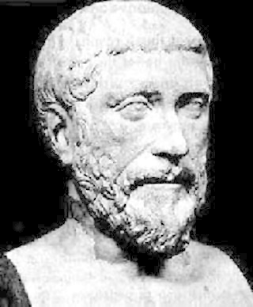

There is no historical evidence that shows reasoning was studied before the time of Plato and Aristotle, however it is likely that such ideas were first developed by studying geometry. Greek philosopher Parmenides is the first philosopher to use an extended argument for his views rather than merely proposing a vision of reality. The Pythagorians determined that there are three basic principles of geometry that must be accepted as true and determine that all other propositions of the system are derived from these. Zeno of Elea uses the “Reductio ad absurdum” technique – drawing an obviously false conclusion from an assumption, and thus demonstrating that the assumption is false. It was Aristotle, however, who was the first to systematically study logic. He established a system of rules and strategies reasoning and was concerned with the soundness of arguments.

Aristotle
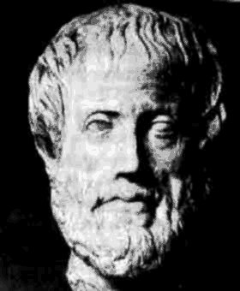

In the 1600’s the philosopher Thomas Hobbes theorized that all logic and reasoning could be reduced to the mathematical operations of addition and subtraction. And then in 1837 George Boole devised and developed a system of algebraic logic that would systematically define and model the function of the human brain. Augustus De Morgan is the individual who helped make the study of logic what it is today. He developed laws relating the logical operators “and” and “or” in terms of each other through the process of negation. De Morgan is also the individual who introduces the term mathematical induction.

A Few Key Terms

Statement: Arguably the most important term, a statement is a verbal expression that can be regarded as either true or false (but not both). Put simply, it is a sentence with a truth-value. We can still regard a sentence as a statement even if the truth-value of the statement is not known.

For example: The sky is blue.
Oranges are green.

Argument: Any group of propositions of which one is claimed to follow logically from the others. By "argument," we mean a demonstration or a proof of some statement.

Parts of an argument:

- Premise: A statement which gives reasons, grounds, or evidence for accepting some other proposition, called the conclusion.
- Conclusion: A statement which is purported to be established on the basis of other statements.

For example: Premise(s): There is a sale at the mall.
I can’t pass up a sale.
------------------
Conclusion: I will be at the mall.

*Note that the form still hold even when all statements are false.*

For example: Premise(s): Red is a number.
Numbers are used to count.
------------------
Conclusion: Therefore red is used to count.

Arguments are made up by a series of statements. These statements can be represented symbolically and strung together using logical connectives. This can be used to simplify complex arguments.

Common Logical Connectives:

Logic | Symbol | English
Conjunctions |  | and
Disjunctions |  | or (inclusive)
Negation | ~ | not
Conditional |  | if... then...
Biconditional |  | if and only if

Laying Low

As he was standing in line to board the 7:00am flight from LA to Chicago, Tommy notices the guy in front of him looks very familiar. Suddenly he knows where he has seen this man before and shouts “Hey, I know you! You’re that guy I saw on ‘SportsCenter’ the other night. Yeah, you’re some baseball or football player or something, aren’t you?” The man trying to hide his identity tells Tommy “I play football or I play baseball. If I play football, then I play baseball.”

- He plays baseball or football
- If he plays football, then he also plays baseball

Rewrite statements (1) and (2) symbolically.

Let P = I play football
Let Q = I play baseball

Can Tommy tell if this man is a football player? Can Tommy tell if this man is a baseball player?

By (1) we can’t have ~P . Therefore if I don’t play football, then I do play baseball and if I don’t play baseball, then I play football. I could play both football and baseball as well.
By (2) if we have P, then we have Q as well. And if we have ~P, then we could still have Q. The only way (2) could be false is if we had P and ~Q.
Therefore it does follow that the man plays baseball, however it is possible that he doesn’t play football.

Laying Low 2

Excited that he has run into this famous baseball player, Tommy wonders if all good baseball players could be good football players. So Tommy asks the man, “Is it really true that if you’re a good baseball player, then you’re also good football player?” The man laughs and replies, “If it is true, then I’m a good baseball player.”

Rewrite the statements symbolically.

Let P = I am a good football player
Let Q = I am a good baseball player

- ()

The lady collecting the boarding passes has only heard this last exchange. Can she determine if this man is a good football player? Can she determine if he is a good baseball player?

Suppose that he isn’t a good baseball player, (1) PQ must be true since the only way this can be false is if we have P and ~Q. But if that is true, then by (2) he plays baseball. This is a contradiction and therefore the only conclusion that follows this argument is that he is a good baseball player. It can’t be determined if he is a good football player.

Playing it Cool!

John was born and raised in Buffalo, NY but John’s new boss Ted is from Boston, MA a city with a history of success in sports. Ted knows many Buffalonians are rabid fans of their hometown teams, so Ted asks John, “Is it true that if you are a Buffalo Bills fan, then you are also a Buffalo Sabres fan?” Like most Buffalonians, John is a little embarrassed by the poor performance of the hometown teams over the last few years, but doesn’t want to lie to his new boss, so he replies ““If it is true, then I’m a Buffalo Bills fan and if I am a Buffalo Bills fan, then it is true.”

Can Ted tell whether John is a Bills fan? Can Ted tell if John is a Sabres fan?

- (

By similar reasoning as the previous problem it follows that John is a indeed a Bills fan. Unlike the previous problem with was a simple implication, in this problem the second statement is a biconditional statement and thus it follows that John is also a Sabres fan.

Darien Lake Disaster?
You and three friends have had the time of your life at Darien Lake Amusement Park. This trip was planned for months and from the start the four of you decided that on any trip to Darien Lake it would be mandatory to ride the three best rides in the park, namely the Viper, the Superman, and the Predator. However halfway through the day you and your friends got into a nasty accident on the bumper cars and can’t remember which rides you’ve been on. After much debate you’re sure the following must be true:

- You have ridden at least one of these three rides : the Superman, the Viper, the Predator.
- If you rode the Superman but not the Predator, then you have ridden the Viper.
- You rode both the Predator and the Viper, or rode neither.
- If you rode the Predator, then you rode the Superman.

Which ride(s) did you ride at Darien Lake?

 | Given
 | Given
 | Given
 | Given
( | Assume
P | By (1), contradicts (2)
 | By (3), we don’t have (
 | By (4)

Another method of finding the solution to this type of problem is through the use of a truth table.
A truth table is a breakdown of a logic problem by listing all the possible values that the function can attain. Such a table typically contains several rows and columns with the top row representing the logical variable and combinations in increasingly complexity.

S | V | P | S | (SV | PS | (P)
T | T | T | T | T | T | T
T | T | F | T | T | T | F
T | F | F | T | F | T | T
F | F | F | F | T | T | T
F | F | T | T | T | F | F
F | T | T | T | T | F | T
F | T | F | T | T | T | F
T | F | T | T | T | T | F

By use of the truth table it is easy to see that the only situation that satisfies all of the four statements is when P, Q, and R are all true (Row 1). Thus, you rode all three rides.

A Solution to the Labyrinth

So do you think you can solve Sarah’s problem?

By asking just one question, Sarah can figure out which door to choose.

We can use the fact that one guard lies and one guard tells the truth to our advantage. By asking one guard what the other would say, we can assure ourselves that we get the false answer.

In other words, if Door 1 one leads to the castle:

  - The Lying Guard would lie and tell us that the Truthful Guard would say it doesn’t.
  - The Truthful Guard would tell the truth and tell us that the Lying Guard would say it doesn’t.

In either case, we know the result is negated. If the response was yes, then we would know that Door 1 doesn’t lead to the Castle.

Represent the following solutions symbolically:

Let A = Door ‘A’
Let B = Door ‘B’
Let C = Leads to the Castle
Let D = Leads to certain Death

(Assuming Sarah asked about door ‘A’) The guard told Sarah that the other guard would say:
AC

But we need to find the negation of that:
~(AC)

Which, in this situation means A D and B C .

Something to think about:

What does the logical connectives?

It would look like this:
In other words, A happens and it doesn’t follow that C happens. So we have A and not C.

