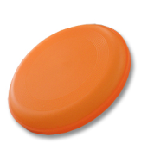 with a Mathematical twist!

Kan Jam is a game played with frisbees where the main idea is to throw the frisbees at a medium sized kan with a top opening and a slit in the front for the frisbee to fit. Hitting the kan or making it into the kan correspond to the points you can get.

**Materials:**

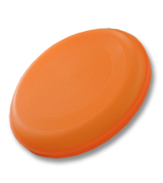 (4) Kan Jam cans

(40) Mini frisbees with math problems on them

Paper and pencils for scrap work and answer

 Masking tape for 1 pt, 2 pt, and 3 pt lines on the floor

Guitar/live entertainment (TBA)

Prizes!!!

**Rules and Instructions:**

* Each group will be split into 3 or 4 teams (parents and kids teams).
* Each team will pick an awesome name, then receive 10 frisbees, with 10 math problems on them.
* You have 6 minutes to answer all 10. Correct answers mean you can throw that frisbee.
* Once grading is done, and the number of frisbees is determined for each team, go to your team’s kan and determine your throwing order. Each team member must throw at least once.
* You will see 1 pt, 2 pt, and 3 pt lines that you can choose to throw from
* If you hit the kan, you get the point value on that line. If you make it in the front slot, or your partner jams it into the top opening of the kan, your team getsDOUBLE POINTS!

**The team with the most points at the end will win a Prize.**



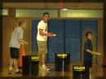

**Sample kid Problems:**

**1.** x + 5= 23 **2.**25x=150 **3.**3x>-6 **4.** x + 4<=5

**5.** Find the GCF 54,80 **6.** Find the LCM 4,14 **7.** Find the Surface Area

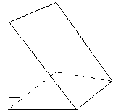

13 in

12 in

6 in

5 in

