Intro to Geogebra
What is Geogebra?
Geogebra is a free, multi-platform dynamic mathematics software that joins geometry, algebra and calculus. Now what does this mean? Geogebra can be used on any computer, Mac or PC.

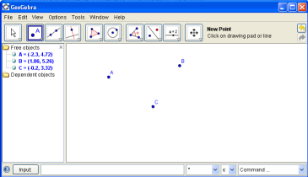

Drawing Pad
Toolbar
Algebra Window
Input Field

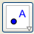
Tools (A list of the basic commands):
- First we will start with the options under the point menu ( ).
- Point ( ): Allows us to place a point, by simply selecting the point option, and then clicking anywhere on the drawing pad to place the point.
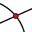
- Intersect Two Objects ( ): Allows us to intersect two lines or curves with a point. This is done by clicking on the two objects that we want to intersect.
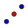
- Midpoint or Center ( ): Allows us to find the midpoint or center of two points. This is done by clicking on the two points that we want to find the midpoint between.
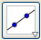
- Second we will take a look through the options under the line menu ( ).
- Line Through Two Points ( ): Allows us to create an infinite line through two points. We can either create this infinite line by using two pre-existing points or by clicking two new points via this tool.
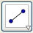
- Segment Between Two Points ( ): Allows us to create a segment between two points. This tool is used the same way as the Line Through Two Points tool.
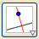
- Third, we will take a look at some of the options under the perpendicular line menu ( )
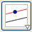
- Perpendicular Line ( ): Allows us to create a line perpendicular to a given line that passes through a chosen point. To do this, after selecting the tool, we click on the line that we want our point to be perpendicular to, and the point we want it to pass through.
- Parallel Line ( ): Allows us to create a line parallel to a given line, and that passes through a given point. To do this, we select the tool, and then click on our given line and our given point.
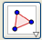
- Next we will take a look at the options under the polygon menu ( ).
- Polygon ( ): Allows us to create a polygon by placing points. To do this we just place each point where we want the sides of our polygon to be. Note that to finish the polygon, we have to click back on our initial point for our ending point.
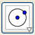
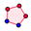
- Regular Polygon ( ): Allows us to create a regular polygon by creating two points and then choosing the number of vertices. To create a regular polygon, we select this tool and then place two vertices. This then brings up a prompt asking for how many vertices we want it to have, we simply put in the numerical value then apply it.
- Now we will take a peek at the options under the circle menu ( ).
- Circle With Center Through Point ( ): Allows us to create a circle where we place a center and that passes through a point we choose. Our first click is the center, and our second click is for the point the circle passes through. We can either make new points or use already created points.
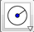
- Circle With Center and Radius ( ): Allows us to create a circle with a specific numerical radius. We create this by either placing a center or choosing a pre-existing point. We are then prompted with an input where we put our desired radius and hit apply.

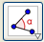
- Next we will check out the options under the angle menu ( ).
- Angle ( ): Allows us to measure the angle between either three points or two lines. To do this we simply click on the three points we want to find the angle between or the two lines.
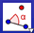
- Angle With Given Size ( ): Allows us to create an angle of a measure that we choose. To do this, we first chose a point for our leg, then our vertex, and finally it prompts us to input our angle.
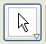
- Now we will check out the move tool ( )
- The move tool is used to select and/ or move objects. By left clicking on an object and holding the left trigger, we can drag objects around our drawing pad. We can use this to move lines, points, polygons and whatever else we would like to move.
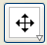
- The final tools we will check out in this section are the tools in the move drawing pad tool menu ( ).
- Move Drawing Pad ( ): Allows us to move around the drawing pad. Through the use of this tool we can scroll around our drawing pad by clicking on the pad and then moving our mouse in any direction.
- Zoom In/ Zoom Out ( / ): Allows us to zoom in or out on our drawing pad (Note: This can also be done with the click wheel of your mouse by rolling it up or down). To use this tool choose either the zoom in or zoom out tool, and then just click on the area you would like to zoom to.

These are just the basic tools that are in Geogebra, there are many more great tools included with this software. So download a copy of this great program, it is free.
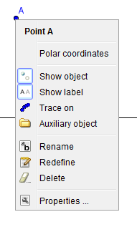

The Power of the Right Click
Sometimes in Geogebra our constructions can get a little bit messy, and that’s where the right click comes in. When we right click an object it brings up a list options on how we can modify that object’s appearance, decide if we want this object to be shown, change its name and much more.

Algebra has a Window of Opportunities (Literally!)
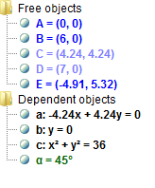
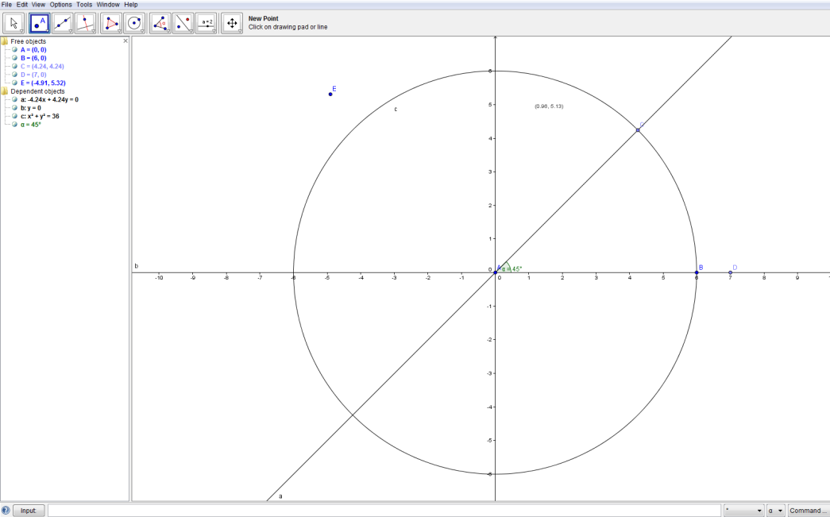
In this section we will examine the Algebra Window and its uses. The main purpose of the algebra window is to translate what we have shown geometrically on our drawing pad, to an algebraic form.

*We notice that all of our objects are translated from a geometrical picture to algebraic form in the algebra window.

- Free objects are the objects that can be directly modified by using either the mouse or the keyboard. Dependent objects are the objects that adapt to the changes of their parent objects (The free objects that it is based upon).

We Value Your Input Field
An alternative way of inputting data is in an algebraic way. We can do this by using the Input Field along with specific types of mathematical code. This is a much more advanced operation than before and will only be looked at briefly in this instruction manual.

- Placing a Point
- To place a point using the input field, we place in the input an ordered pair equal to a letter we want to denote it. Suppose we wanted to plot a point A at (2,2), we would type A=(2,2) into the Input Field.
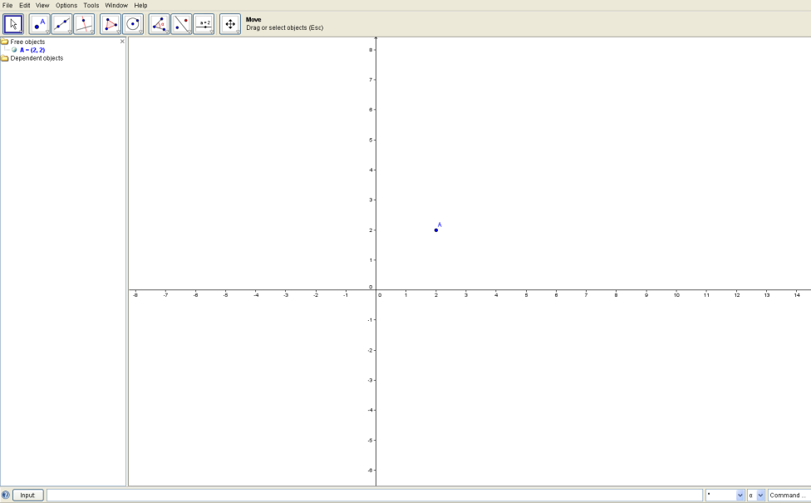

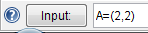

- Inputting an Equation
- To put an equation into Geogebra, we type in the equation into the Input Field in terms of x and y. For example, say we wanted to graph${ x}^{2}+y^{2}=9$.
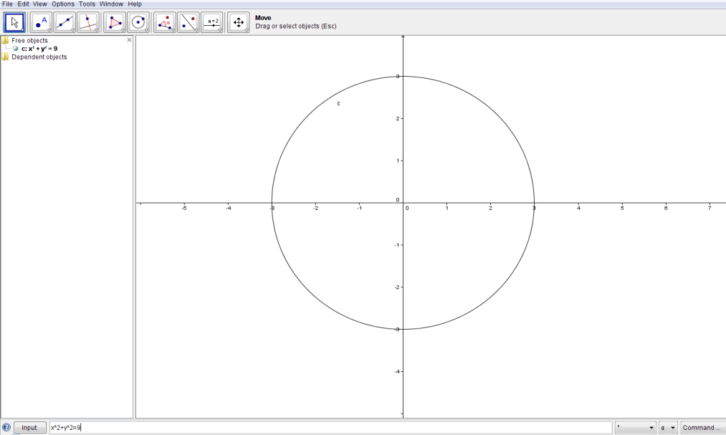

We hope you enjoyed our go-to-guide for basic Geogebra. I hope you had as much fun as we did!

