Megan Krotje Catherine Leichner Vanessa Love- McCarthy
Krot4494@fredonia.edu leic2647@fredonia.edu love7989@fredonia.edu

Cheezy Fractions

This lesson is designed for the New York State Grade 6 Curriculum. Prior to the instruction of this lesson students should have some basic knowledge of how to compute the four main operations (addition, subtraction, multiplication, and division) with fractions. The purpose of this lesson is to review those operations in context using word problems. Instruction is designed to fit a 40 minute class period.

This lesson addresses the following NYS MST Standards/Performance Indicators for Grade 6:
6.PS.3 Interpret information correctly, identify the problem, and generate possible strategies and solutions
6.PS.5 Formulate problems and solutions from everyday situations
6.CM.4 Share organized mathematical ideas through the manipulation of objects, numerical tables, drawings, pictures, charts, graphs, tables, diagrams, models, and symbols in written and verbal form
6.CN.3 Connect and apply mathematical information to solve problems
6.CN.6 Recognize and provide examples of the presence of mathematics in their daily lives

This lesson also addresses the following NCTM Principles and Standards in school Mathematics Grades 6-8:
Algebra Standard- Model and solve contextualized problems using various representations, such as graphs, tables, and equations
Problem Solving Standard -build new mathematical knowledge through problem solving
Problem Solving Standard- solve problems that arise in mathematics and in other contexts
Communication Standard- use the language of mathematics to express mathematical ideas precisely

Following the conclusion of the lesson students should be able to:
- Recognize when to compute each specific operation using fractions based on the context of a problem
- Given key words, recognize which operation to compute
- Solve word problems dealing with fractions

We start this lesson with a fun problem about pizza and what fractional portion of that pizza the certain topping covers. In order to solve this “hook” we ask the students to draw out the problem and use their problem solving and reasoning skills to arrive at the final answer. Next, we display in the form of a chart some key words that word problems use to tell the students what operation to use to solve the problem. The students are to fill in the chart with the correct operations (which will be reviewed once all students have completed the chart). The guided practice section of our lesson is a math cartoon with word problems following it. The object of this activity is to have the students work together in small groups to solve the word problems and to promote communication of the mathematics.

NAME: ___________________
Cheezy Fractions

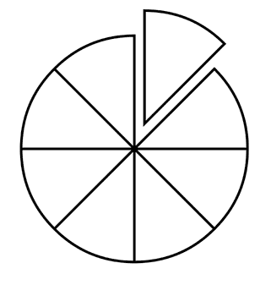
Mike ordered a pizza that had 8 slices in all. Half of the slices had pepperoni, 1/4 had mushrooms, 1/8 had peppers. The rest of the slices had cheese only. How many of the slices had just cheese? Color in the toppings to discover the answer.

Answer:_______________

Word Problem Vocabulary
Phrase | Operation
LEFT OVER
REMAINING
DIFFERENCE BETWEEN/OF
LESS THAN
FEWER THAN
MINUS
DECREASED BY
ALL TOGETHER
COMBINED
INCREASED BY
MORE THAN
TOTAL OF
SUM
ADDED TO
AND
OF
TIMES
MULTIPLIED BY
PRODUCT OF
PER
OUT OF
RATIO OF
QUOTIENT OF
PERCENT
IS
ARE
WAS
WERE
WILL BE
GIVES
YIELDS
Name:______________

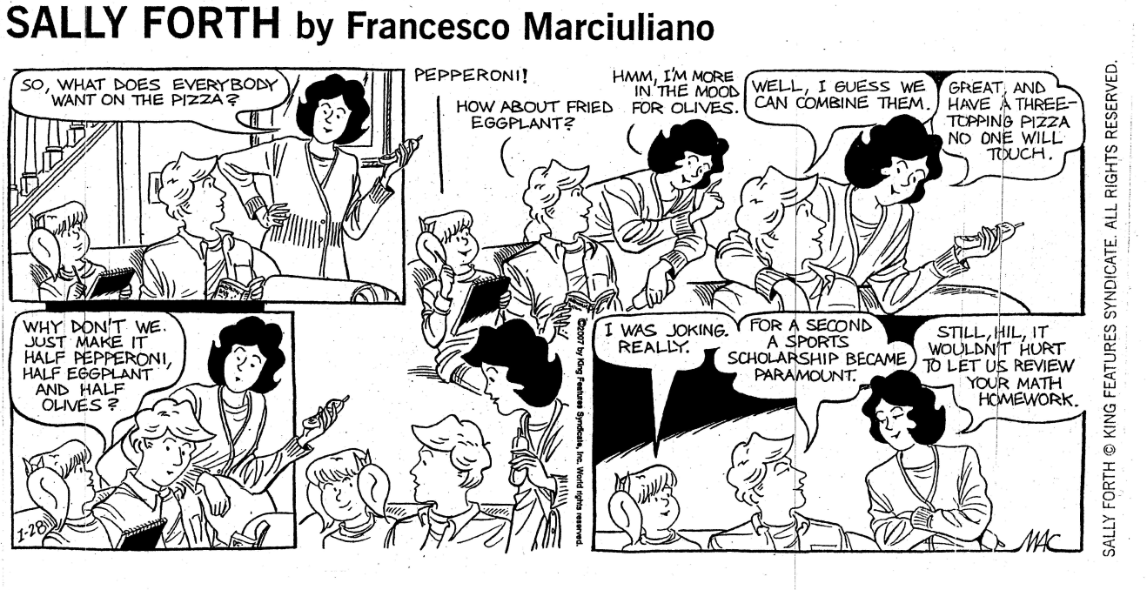

- Why are Hilary’s parents worried about checking her math homework?

Suppose the pizzeria is offering a “Buy two, get one free” special, so the family orders 3 medium pizzas. Mom’s pizza has Olives on it, Dad’s pizza has eggplant on it, and Hilary’s pizza has pepperoni on it.

- If mom eats 2/6 of her pizza, dad eats 4/6 of his pizza and Hilary eats 1/2 of her pizza, how much total pizza is left? (Draw a picture to illustrate this and help you find the solution.)

- Afterwards, grandma visits and eats 1/6 of each pizza. What fraction of total pizza is left?

Teacher Copy
Cheezy Fractions

Mike ordered a pizza that had 8 slices in all. Half of the slices had pepperoni, 1/4 had mushrooms, 1/8 had peppers. The rest of the slices had cheese only. How many of the slices had just cheese? Color in the toppings to discover the answer.

Answer: 1 slice

Word Problem Vocabulary
Phrase | Operation
LEFT OVER  REMAINING  DIFFERENCE BETWEEN/OF  LESS THAN  FEWER THAN  MINUS  DECREASED BY | SUBTRACTION
ALL TOGETHER  COMBINED  INCREASED BY  MORE THAN  TOTAL OF  SUM  ADDED TO  AND | ADDITION
OF  TIMES  MULTIPLIED BY  PRODUCT OF | MULTIPLICATION
PER  OUT OF  RATIO OF  QUOTIENT OF  PERCENT | DIVISION
IS  ARE  WAS  WERE  WILL BE  GIVES  YIELDS | EQUALS
Teacher Copy

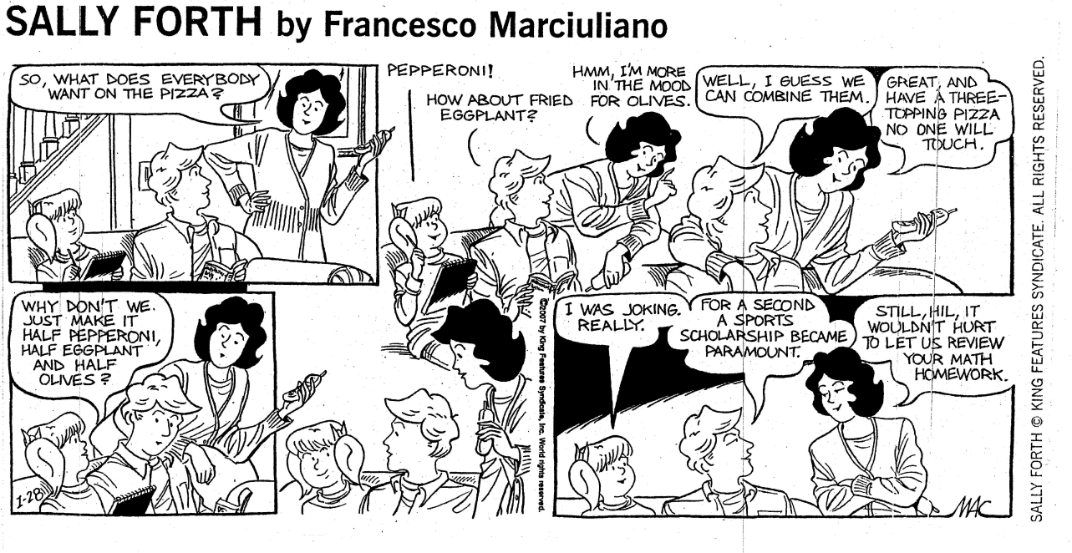

- Why are Hilary’s parents worried about checking her math homework?

Three halves of a pizza would equal 1 ½ pizzas, which is more than one pizza.

Suppose the pizzeria is offering a “Buy two, get one free” special, so the family orders 3 medium pizzas. Mom’s pizza has Olives on it, Dad’s pizza has eggplant on it, and Hilary’s pizza has pepperoni on it.

- If mom eats 2/6 of her pizza, dad eats 4/6 of his pizza and Hilary eats 1/2 of her pizza, how much total pizza is left? (Draw a picture to illustrate this and help you find the solution.)
Allow shades slices to be the slices eaten & non-shaded slices to be the slices left over.
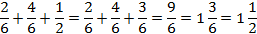

- Afterwards, grandma visits and eats 1/6 of each pizza. What fraction of total pizza is left?
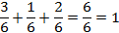

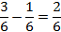

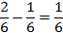

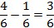

Helpful Hints for Teachers

Common Misconceptions
- Seeing the numbers in a fraction as two unrelated whole numbers separated by a line
  - “2/3– that’s two and three”
- Treating fractions in the same way as whole numbers
  - “1/3+ 1/4= 2/7”
- Being influenced by appearances
  - “1/4= 1.4”
- Thinking that it is only the denominator that determines the size of the fraction
  - “4/5>1/3because 5 >3”
- Not being able to judge that an answer does not make sense
  - “1/2+1/2= 2/4”
- Not understanding the concept of fractional parts
  - “Anything less than a half is a quarter” or “1/3, that’s the same as 1/4isn’t it?”
- Not understanding what to do with a remainder and what 0.1 actually represents
  - “7/2=2.1 because three goes into seven twice with one left over”
- Not understanding that one third is the same as dividing by three
  - “1/3of 30 is … 3 ?”
- Not having sufficient experience of fractions as parts of sets of objects
  - “3/4of 12 pens is … four because that’s quarters …?”
- Not understanding the relationship between the fractional part and the unit
  - “There are three quarters in a whole because two is half”
- Confusion about “tens” and “tenths”, “hundreds” and “hundredths” because they sound the same
  - “2/10– that’s two tens”

Key points to remember
- Learners should understand that one way of thinking about a fraction is to see it as the result of dividing the top number equally into the number of pieces shown by the bottom number.
- A key point is that the denominator (bottom number) of a fraction shows how many equal parts a number, or an object, or a set of objects, has been divided into. The numerator (top number) tells us how many of those parts there are.
- Learners need to be familiar with multiple representations of fractions, and should always be given more than one representation. These can include: area diagrams using a range of different shapes, number lines, words, symbols, some decimal equivalents and percentages, fractions as a result of division.
- Compare unit fractions with different denominators (e.g. 1/3, 1/4, 1/5).
- Compare fractions with the same denominator (e.g. 1/5, 2/5, 3/5).
- Encourage strategies for deciding whether a fraction (unit or non-unit) is less than half, equal to half or greater than half.
- Consider the difference between a unit fraction and a whole unit (e.g. 1–1/4 or 1–1/5).
- Show that fractions can be equal to, or bigger than one whole.

References:

Fraction Concepts. Fredonia, NY: Kim Conti. Print.

Marciuliano, Francesco. "SALLY FORTH." Comic strip. Mathematics Teaching in the Middle School. 9th ed. Vol. 14. National Council of Teachers of Mathematics, May 2009. 516-18. Print.

McLeod, Rachel, and Barbara Newmarch. "Fractions." National Research and Development Centre for Adult Literacy and Numeracy, 2006. Web. 29 Oct. 2009. <www.nrdc.org.uk>.

