Jordan Bardo Paul Chimenti Donnie Kirsch
bard5286@fredonia.edu chim3695@fredonia.edu kirs1187@fredonia.edu

Introduction:
This lesson incorporates fun ways of working with rates, ratios, and proportions. It is intended for an eighth grade math class.

Relevant Professional Standards:
- 8.PS.10 Use proportionality to model problems
- 8.M.1 Solve equations/proportions to convert to equivalent measurements within metric and customary measurement systems

Major Instructional Objectives:
Following the conclusion of this lesson, students should be able to:
- Use rates, ratios, and proportions to solve realistic problems.
- Solve problems involving more than one proportion.
- Create awesome cardboard cutouts.

Instructional Protocol/Itinerary:
Students will be presented with three separate “hook” type activities. They will work in groups and receive guidance as needed. Each activity is designed for a 50 minute class period. Activity 1 – Faster Than a Clicking Thumb is a contest to see who can calculate a distance using speed and time. Students will measure the velocity of a ball that is thrown an estimated distance. Simultaneously, they will measure the time it takes the ball to travel this estimated distance. They will calculate the actual distance using these measurements. Finally, they will find whose calculated distance was closest to the estimate. Activity 2 – Ratio Stations will allow students to move around stations and solve problems involving proportions. At one station, students will mix water and food coloring. The color that emerges will tell them if they have calculated correctly. At another station they will make a batch of play-doh which is proportional to a given recipe. Again, comparison to a premade product will determine the accuracy of the calculation. At the third and fourth stations, students will weigh various volumes of water and sand. After the first measurement, they will make predictions about the weight of a different known volume. Activity 3 – “Mini YOU” will allow students to produce scale drawings of their classmates. Students will trace each other and the record measurements of various body parts. They will then use proportions to make a scale drawing of the traced figures. All three activities will include questioning to check for understanding along with the calculations.

Materials Needed:
The individual lessons in this packet will provide the educator with the proper insight and materials needed to complete the activities.

Faster Than a Clicking Thumb
Did you know that you can calculate distance using just a radar gun and a stopwatch? That is our activity for today. The class will be split up into groups. Depending on the weather, we will be working outside or in the gym today. Bring this paper so you can fill in the table. Below is a step-by-step list for this activity.
- Send a pitcher and catcher to different places that you estimate to be 60 feet 6 inches apart.

- The pitcher throws to the catcher.

- Record the data for speed and time (the radar gun and stopwatch operator will need to stand behind the catcher but away from the approaching throw).

- Record the data from the other groups and fill in the table.

Team Speed Time Distance

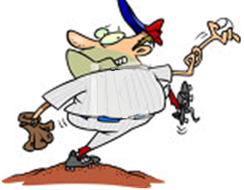

Note:
You can follow our activity on YouTube at http://www.youtube.com/watch?v=HYOsDIHP5ZU
Or you can search for us under “Faster Than a Clicking Thumb”
Use the measured speeds and times as well as the following formula;
$$speed=\frac{distance}{time}$$

Use this formula to find the formula for distance. State this formula.

Hint: The speed is recorded in miles per hour, the distance in feet, and the time in seconds. Make sure all measurements are using the same units before calculating.

Think about it…

What factors could make this distance calculation inaccurate?

Is the ball traveling at the measured speed for the entire distance? If not, how will this affect the calculation?

Faster Than a Clicking Thumb Solutions

Sample calculation:

If the speed is 50 mph and the time is 0.70 seconds

First convert 50 mph to ft/sec as follows:

$$50 miles ∙5280 feet per mile=264000 feet$$

$$1 hour=3600 seconds$$

Therefore,

$$50 mph=\frac{264000}{3600}≈73.3 ft/sec$$

Now multiply by the time

$$73.3 ∙0.70=51.31 feet$$

This team’s estimate of 60 feet 6 inches was not quite accurate.

Think about it:

The stopwatch operator is most prone to error. It is hard to start and stop quickly. Of course, an error in calculation will yield an inaccurate result. Another factor is that the ball is not traveling at a constant speed.

The ball will not be traveling at a constant speed. If the recorded speed is higher than the actual speed, the distance will be calculated as farther away than it actually is.

NOTE: The class can also measure their distances to see how accurate their calculations were. Mathematical error and stopwatch error would be the most likely contributing factors to an incorrect distance calculation.

Ratio Stations

Station 1

The objective of this activity is to reproduce a miracle cure for a man diagnosed with “poor-ratio-itis”. The cure’s formula is given to us as a mixture of two others:

Beaker 1: 16 fluid ounces of water and 4 drops of red coloring
Beaker 2: 1 pint of water and 8 drops of blue coloring

Unfortunately, we cannot use such a large amount so we must create two new mixtures. We would like a dose that is ¾ of the original cure.

Conversions are helpful. Hint: 1 cup= ½ pint and 4 fluid ounces = ½ cup

List the ingredients for the two new beakers. Label water in fluid ounces.
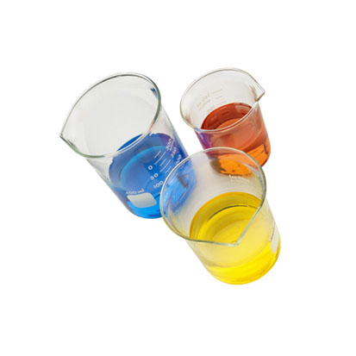
Beaker 1:

Beaker 2:

Add these two mixtures together to get the magical cure.

Does your cure have the same characteristics as the original? Explain.

If we added both cures together, how much liquid would we have (in fluid ounces)? Show your work.

Think about it…
Is it true that our new cure is ¾ of the original? How can you tell?

Is it possible to have the incorrect measurements and still obtain the correct cure?

Station 1 Solutions

Beaker 1:

$$\frac{3}{4}∙16=12 fl oz of water$$

$$\frac{3}{4}∙4=3 drops of red coloring$$

Beaker 2:

$$1 pint=2 cups=16 fl oz$$

$$\frac{3}{4}∙16=12 fl oz of water$$

$$\frac{3}{4}∙8=6 drops of blue coloring$$

When the contents of the two beakers are combined, the resulting solution should look identical.

If added together, we would have

$$12+12+16+16=56 fl oz.$$

Our new cure is ¾ of the original because

$$\frac{24}{32}=\frac{3}{4}$$

The individual beakers could have the incorrect amount of water and still yield the correct final product as long as the total amount of water is correct. The coloring needs to be correct.

Station 2

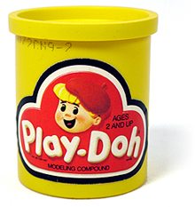
The students are given a ball of play-doh and the ingredients that were used to make it. However, there are not enough materials for the whole class to make a piece so large. In fact, the goal will be to recreate a chunk of play-doh that is 1/4 of the given piece. If the correct procedure is followed, the dough will be the same consistency and color as our original chunk.

The ingredients for the original ball:

3 cups flour
1/3 cup salt
2 tablespoon vegetable oil
1 cup water
8 drops of blue coloring

Useful hints for measuring:
1 Cup = 16 tablespoons
1 tablespoon = 3 teaspoon Method for mixing the play-doh:
Mix flour and salt with oil. Add food coloring to water and stir. Combine the two mixtures slowly while mixing together with a spoon. Knead the dough with your hands.

What is the first step in creating your new recipe?

List the amount of each ingredient in your new recipe.

Flour:
Salt:
Vegetable Oil:
Water:
Coloring:

Think About it
Does your piece compare to the original? Describe similarities and differences.

If the new piece is different, what are possible problems?

Are there any other ways to check that our product is 1/4 of the original?

Station 2 Solutions

The first step is to ¼ of each ingredient.

Flour:

$$\frac{1}{4}∙3=\frac{3}{4}cup of flour$$

Salt:

$$\frac{1}{3}∙\frac{1}{4}=\frac{1}{12}cup=\frac{16}{12}=\frac{4}{3}tablespoons=4 teaspoons$$
Oil:

$$2 ∙\frac{1}{4}=\frac{1}{2}tablespoon$$

Water:

$$\frac{1}{4}cup$$

Coloring:

$$\frac{1}{4}∙8=2 drops$$

Think about it…

The new play-doh should have the same color and consistency.

Any inconsistency would be caused by an error in calculation.

The weight and volume of the new should be ¼ of the original.

Volume can be found using displacement.

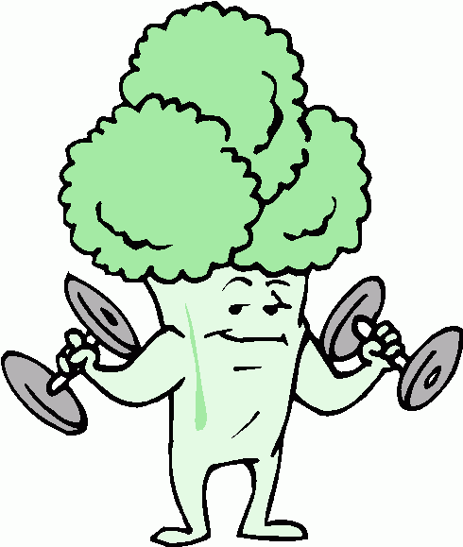
Station 3:
Participants in the world’s strongest man competition are asked to lift as much water and sand as possible. The sand and water come in containers with the weight given. If the participant would like to lift twice as much sand or water, will the container have twice the volume?

Measure 250 mL of water. How much does it weigh?

Now measure 500 ML of water. What do you predict that it will weigh? How much does it actually weigh?

Now measure 1 L of water. What do you predict that it will weight? How much does it actually weigh?

Now repeat the process using the same measurements of sand rather than water. Record them below.

Think about it…
What factor(s) could make the measurements less accurate?

Which substance allowed you to make a better prediction? Why?

Could this process be used to predict the weight of any substance?
Station 3 Solutions

The water should have a ratio of mL to g of 1:1.

250 mL = 250 g

500 mL = 500 g

1000 mL = 1000 g

Depending on the sand used, it should weigh approximately 1600 g per 1000 mL.

250 mL = 400 g

500 mL = 800 g

1000 mL = 1600 g

For both, the ratio should be established from the first calculation and used to make accurate predictions. Also, the container used to weigh the water and sand should be subtracted from the total weight.

Think about it…

Failure to subtract the weight of the container, inaccurate measurements, and inaccurate calculations can make the predictions incorrect.

In most cases, the water should be more predictable because it is more consistent and easier to measure. Of course, the 1:1 ratio makes it easier as well.

Not all substances have a proportional relationship between volume and mass.

Mini YOU

Doctor Evil wanted a clone and Mini Me is what he got. They are known for being the same person in a ratio of 1 to 8. So…if you wanted a clone, could you make a mini you?
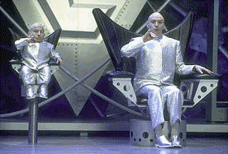
Materials needed:
- Pens/Pencils
- Large Rolls of Paper: Approximately
6ft. x 4ft.
- Plain Paper: 8 ½” by 11”
- Students
- Measuring tool
  - (Tape measure or yard stick)
Directions:
- Get into groups of two or three.
- Have one person lay on the large piece of paper. The other two will trace.
  - (Do this until everyone has their own outline)
- Take turns using the measuring tool and measure the length of the body parts.
  - ( Remember to record the measurements in the table below)
- Using your recorded measurements, come up with a ratio to put the large you on the smaller piece of paper.
Example:
Find the scale factor:
I am 6ft tall. We have a paper that is 8½” x 11”. Using the steps above, transform my large image into a smaller one.

Body Part | Measurement  (inches) | End Result  (scale)
Height of Body
Top of Head to Chin
Chin to Collar Bone
Shoulder to Elbow
Elbow to Tip of Middle Finger
Collar Bone to Waste
Waste to Knee
Knee to Ankle
Heel to Big Toe

Think about it…
Would it be more accurate to draw with more measurements or fewer?
Mini YOU Solutions

Example:

$$\frac{6ft}{xin}=\frac{1ft}{12in} where x is the missing number of inches. Therefore, x=72 inches.$$

$$If the paper is 11 inches tall, and I am 72 inches tall, the scale factor is \frac{11}{72} ≈ 0.153$$

$$If I measure from the top of my head to my chin to be 1 ft.How big will it be on the smaller piece?$$

$$We know 1foot=12inches$$

$$\frac{12inches}{x}=\frac{1inch}{0.153inch} where x is the number of inches on the smaller paper$$

$$Therefore, the height from the top of my head to my chin ≈1.84 inches$$

We can use fewer measurements; however, the final product may not be as accurate as the one using more measurements.

