Josh Sadler, Robert Rappole, Michelle Swackhammer
Equation Editor
Creating an Equation Editor Toolbar (Microsoft Office)
- 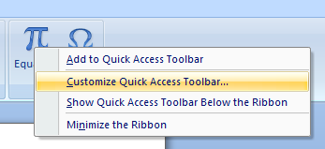Click on Insert, and then right click on Equation.
- Click ‘Customize Quick Access Toolbar’.
- From here, click on the drop down menu at the top left of the window and select ‘Equation Tools | Design Tools’
- Now click and add each tool you would like to be used on your toolbar, i.e., ‘Fraction’, ‘Integral’, ‘Function’, etc.
- You can find your toolbar at the top of the screen next to the office button:
- The Toolbar can also be moved to just above your document for easier access by clicking on the drop down arrow at the end of the Quick Access Toolbar and then clicking ‘Show Below the Ribbon’
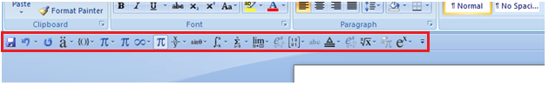
Turning Linear Notation into Professional Notation
- Enter a new equation by pressing alt + =
- Enter an equation in linear notation:

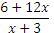

- Once you hit enter or space, the equation will turn into the professional notation:

- To change it back to Linear, simply right click and select ‘Linear’
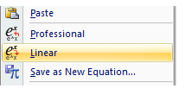

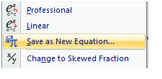Saving an Equation
- Right-Click on the equation you would like to save, then select ‘Save as New Equation’
- Next to ‘Name:’, type in what name you would like the equation to be called, then click ok
- 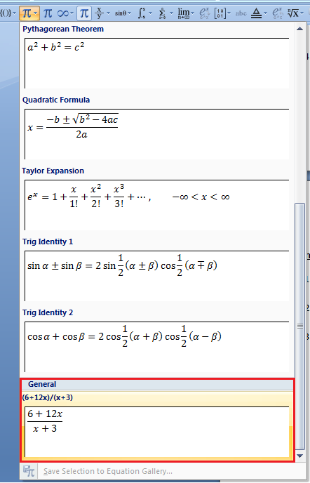Now go to the Quick Access Toolbar and select the Equation Button. Scroll down to General, and there is where the equation has been saved.

MathType
- 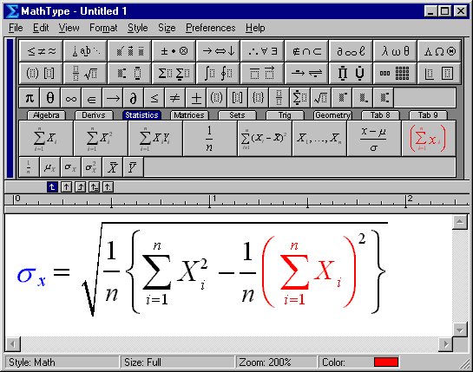A beefed up version of Equation Editor
- It can work with many types of equations and use many different symbols
- MathType users can create equations for Microsoft Word documents and PowerPoint presentations, MathType also works with many other applications and websites and they are adding more and more every day

- Keyboard Shortcuts: MathType has customizable keyboard shortcuts for virtually every symbol, template, and command.
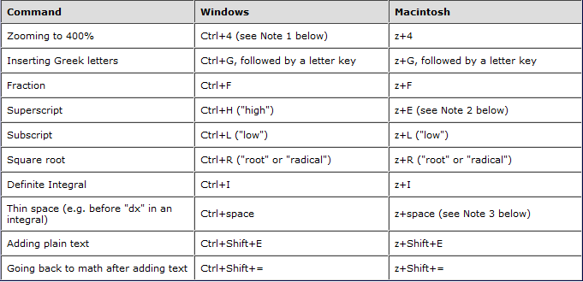

- For more Tips and Tricks: http://www.dessci.com/en/products/ee/ee_tips.htm#other_apps

