Robert Longton Trevor Nelson Robert Rappole

[long4153@fredonia.edu](mailto:long4153@fredonia.edu) [nels4673@fredonia.edu](mailto:nels4673@fredonia.edu) [rapp0384@fredonia.edu](mailto:rapp0384@fredonia.edu)

Creating Constructions Since 300 B.c.

**Introduction**

This lesson plan is divided into three separate activities. It starts with a brief overview of the history of constructions. After which, students will participate in a poster creation contest following a lab with the Geogebra application, which will help them see precise constructions before creating them. Finally, a class activity will have students get into the outdoors and create a construction with nothing but a length of string and a piece of chalk.

**NYS MST Standards/Performance Indicators**

* 5G13: Plot points to form basic geometric shapes (identify and classify).
* 6G1: Calculate the length of corresponding sides of similar triangles, using proportional r reasoning.
* 8G0: Construct the following using a straight edge and compass: Segment congruent to segment; angle congruent to an angle; perpendiular bisector; and angle bisector.
* 4G3: Find the perimeter of polygons by adding sides.

**NCTM Principles and Standards**

* Make and investigate mathematical conjectures
* Select and use various types of reasoning and methods of proof
* Use coordinate geometry to represent and examine the properties of geometric shapes
* Draw geometric objects with specified properties, such as side lengths or angle measures
* Analyze and evaluate the mathematical thinking and strategies of others

**It Is All Greek To Me**

**Introduction**

This portion of the lesson is designed to give students the background knowledge that leads into Constructions and the planned activity. It will cover largely Greek mathematics in Geometry, the basis for constructions.

**Objectives**

Following the completion of this portion of the lesson, students should:

* Be able to explain the principles behind Greek Geometry
* Be able to perform some minor constructions with a straightedge and a compass

**Materials**

* Compass
* Straightedge
* Paper
* Colored Pencils

**Procedures**

1. A Little History (4 mins)

For this portion, we will use a slideshow presentation which covers many of the basic definitions and postulates from Euclid’s Elements. We will cover how Euclid says to make things such as straight lines and circles, how to increase the scale of lines and circles, and how these notions are connected to constructions. While we go into the definitions and postulates we will show images of how to construct things in Euclid’s Elements with a compass and a straightedge.

1. Your Turn (1 mins)

For this portion we ask kids to get creative. We will ask them to draw certain things in certain ways to challenge their ability to create lines and shapes. (i.e. Draw two circles connected at a single point and connect their centers with a single straight line. Then form a circle which has the previous straight line as its diameter.) Students will have a chance to mess around with constructions and become a little familiar with them on their own terms. After this is done they will move on to the main activity.

**Contest of Construction**

**Objectives**

This activity will allow students to practice recognizing shapes that are created within multiple constructions, as well as create their own constructions.

**Materials**

* Compass
* Straightedge
* Paper
* Colored Pencils

**Lesson Procedure**

Give an explanation of constructions: Any type of geometric design created using a compass and straightedge. (5 minutes)

1. Pass around pictures of constructions. (2 minutes)
2. Explain the 4 Color Theorem: Any 2-Dimensional Map divided into shapes can be colored so that each shape is a different color from all the others that border it. (5 minutes)
3. Explain class activity:
   1. The class is going to divide into groups.
   2. The class will then be given constructions and told to color all separate shapes within the construction using as few colors as possible while not having two shapes of the same color touch.
   3. Groups will also identify as many polygons as they are able to. In other words all shapes composed of sides with straight lines.
   4. After the first construction, a second construction will be given of greater complexity, namely more polygons within the construction.
   5. After a few, they will use compasses and create their own constructions.
   6. Each student will pass their construction to another student to color using the fewest number of colors that they can.

(30 minutes)

1. Take a construction of fairly simple design, such as a plane 6-sided star within a circle, and have the class make recommendations as to where a line could be placed to divide the construction into more regions. Each time, color in the regions. This is to show the students how more than 4 colors will never be used to color in the regions.

Sample Constructions:

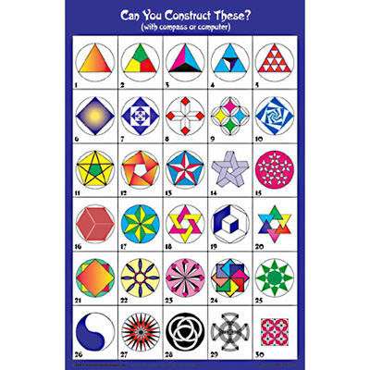

These are constructions, many of which are simple to create, others more complex. The activity would start with simple designs such as number 26, or the first row, but colorless. It is up to the student to determine colors, and how many to use.

**GeoGebra’s Future Creations**

**Objectives**

* This lesson is about identifying and creating geometric shapes, using GeoGebra and is intended for the 6th-7th grade level. Students will be given a lab which will guide them through how to use GeoGebra. This lab will also ask questions of the student, while they are being walked through. This will help the students make connections between what the computers are doing and what people making the shapes by hand are doing.
* Following the conclusion of the lesson students should be able to…
  + Use GeoGebra to construct regular polygons inside a circle
  + Find the area of each regular polygon
  + Find the perimeter of each regular polygon
* The protocol for this lesson will be…
  + Start by showing how to create an equilateral triangle inside a circle
    - Find area/perimeter of triangle
  + Work with other regular polygons
    - Find area/perimeter of other regular polygons

**Materials**

* Computer
* Geogebra

**Procedure**

Constructing a equilateral triangle:

1. Start by going to view on the tool bar and selecting to show grid.
2. Place a point (A) at the coordinate (6, 6) (in actuality the point could be at any coordinate, but for the sake of making the example consistent, we will you (6,6)) .
3. On the tool bar select the “Circle with center through point” button and then click your point A.
4. Once you select the point, move your mouse to the coordinate (2, 2) and click again (you should now have a circle with center point A at (6, 6) and point B on the circle at (2, 2)).

Q:How would a person make a circle without Geogebra?

1. There are little white triangles in the bottom right corners of each of the construction options on the tool bar. Click the little white triangle in the bottom right corner of the “Angle” button and select “Angle with given size”.
2. After this click on point B then click on point A. A window should open with a place to type your desired angle. Without deleting the degree sign, delete the 45 and type (360/3). Then hit apply. Explanation: The 360 is how many degrees in a circle and the three is how many angles in a triangle.

Q: What tool would a person use to complete this step?

Q: What tool did Geogebra use?

Q: Why do you think it matters that there are 360 degrees in a circle and three angles in a triangle?

1. After hitting apply, you should notice a new point B’ on your circle and that there is an angle of $120°$ on point A.

Q:120? Why is the angle 120?

1. Next click the little white triangle in the bottom right corner of the “Polygon” button and select “Regular polygon”.
2. Click on point B and B’ and when the window pops up enter 3 for the number of sides you desire and click apply.

Q: Why did we enter 3?

1. YES!!!! A equilateral triangle has been born. If you look on the far left, you should see a box with all your points and lengths of segments and such. You should see a=9.8, b=9.8 and b’=9.8, and poly1=41.57. a,b,b’ show that all three legs of your triangle are equal in length. To find the perimeter of this triangle all you have to do is add all three of these together. The area of the triangle is poly1=93.53.

Q: What is the perimeter of this triangle?

1. You can play with this triangle by clicking and holding the point B and dragging it around. The lengths of all three legs should always be equal to each other, no matter where you drag the point B.

Now try a few yourselves and have fun with it:

Make sure to check the lengths of the sides of any shape you make, if you want to show the shapes are regular polygons

Q: What does a 6 sided regular polygon look like?

Q: What about a 8, 9, or 10 sided regular polygon?

Q: Do you get a regular polygon if you use a 7, or 11 sided figure?

Q: If not, why might that be?

**C:\Users\long4153\AppData\Local\Microsoft\Windows\Temporary Internet Files\Content.IE5\G3C140V3\MCj03291910000[1].wmf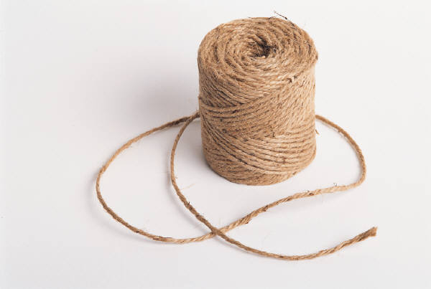The String Thing**

**Introduction**

This lesson provides students with the opportunity to have fun making shapes with sidewalk chalk and some rope. It is intended to immediately follow a lesson and/or activity on the subject of constructions. This lesson is driven by discovery learning, allowing students to experiment with construction-type ideas in order to attempt to create the perfect square! This lesson should take no more than fifteen minutes for a full class, less if you have a small group of kids.

**Objectives**

Following the completion of this lesson, students should:

* Have a clearer understanding of constructions and the related principles
* Better understand Euclidean Geometry (if they have been taught any)
* Enhance their interest in geometry and constructions
* Be able to use their creativity and reasoning to perform other constructions

**Materials**

* Sidewalk chalk (get many different colors)
* Long amounts of string (more than 2 meters or 2 yards is preferable) the string will serve as both a compass AND a straightedge! (the string can be pulled taught and serve as a straightedge)

**Procedures**

1. **General Setup**

Students will need an open parking lot or some large area with lots of space to make their constructions. A suitable area should be a minimum of 100 square feet. Also you should try to get an area which is relatively smooth: cracks, holes, etc. will frustrate the students’ efforts to draw their lines.

You should split the class up into teams so that they as groups will not need too much room. Teams of 3-4 should work well, but you should take into account how much space you can give them and split up teams to ensure everyone can get enough space in which to work.

1. **The Activity – Guided Practice**

Students should be set loose for a while with the starting instruction that they should begin with a circle. Students should also use differently colored chalk at every different step so that their steps are a little easier to spot in the finished product.

The teacher should stay just beyond the zone of proximal development, giving the students room to work independently. While the students are working, the teacher should be walking around observing, and offering advice to the whole class when the class is struggling. There is no single right way to do this activity so students should make an effort to be creative, but the teacher should offer help.

1. **Wrap-Up**

The teacher should measure the diagonals of each group’s square. The teacher should take the smaller diagonal divided by the larger diagonal, and whichever group’s proportion is closest to 1 has the “perfect square” (or most perfect square)!

The entire class should have a chance to see what the other groups did, to give them a chance to see how they could have done things differently. The teacher should give extra attention to the group that got the closest, asking the students from that group to explain their methods step-by-step to the rest of the class. The types of questions the teacher should be asking the students are “how is this different from what you did?” and “why does this work?”