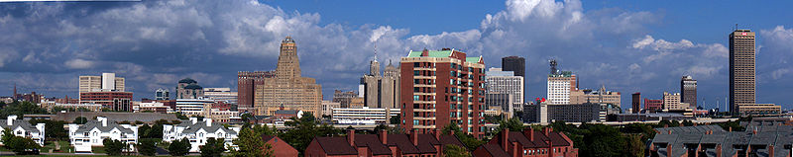

**How much do you know about the City of Buffalo?**

The **HSBC Tower** takes up 1.2 million square feet of space and is 40 stories tall, which makes it the tallest building between Cleveland and Albany.

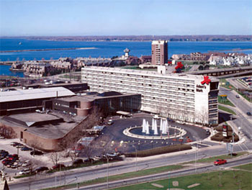

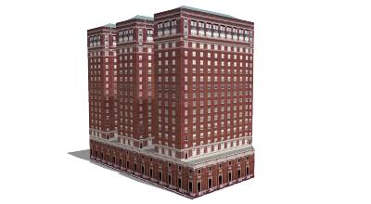

The Statler Hotel A.K.A the **Statler Towers** stands 265 feet tall and was completed in 1923. The hotel has 450 rooms.

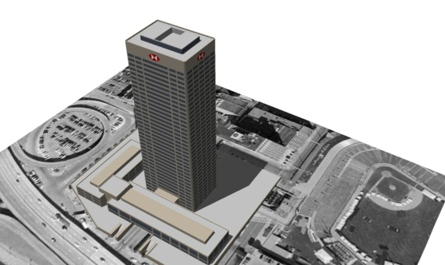

The **Adam’s Mark Hotel**, which had been previously been named the Hilton Hotel, was added to the City of Buffalo in 1989. It is 72,000 square feet and has 486 rooms.

The **HSBC Atrium** Building is one of the newest office buildings in Downtown Buffalo. It is an all glass façade and is currently home to the HSBC Bank.

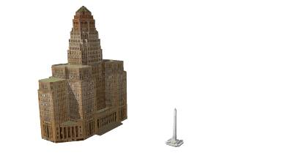

**Coca-Cola Field,** formally known as Dunn Tire

Park, seats 19,500 fans. It hosted its first regular season game on April 14, 1988. In the Bisons’ first season they became the first minor league team to draw over 1 million fans.

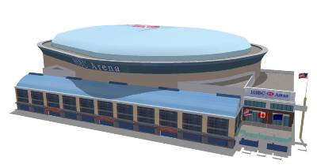

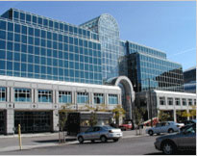

**City Hall** stands 398 feet tall with 32 stories and was built by Kurt Russel in 1931. It was considered the tallest building until the 1970’s.

The **McKinley Monument** is located in **Niagara Square**. In 1807 Niagara Square was in fact a square created from the four streets surrounding it. However, presently Niagara Square is actually a circle. This memorializes President William McKinley.

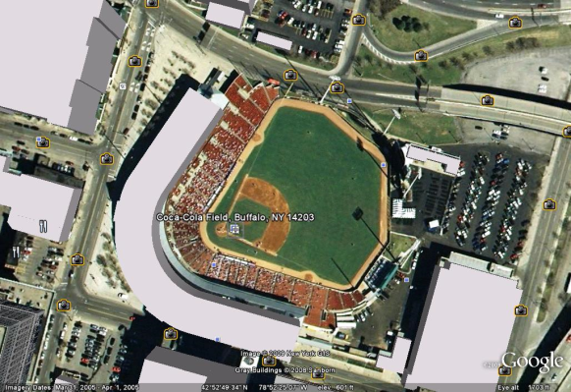

The **HSBC Arena** replaced the Buffalo Memorial Auditorium. The HSBC Arena is now home to the Buffalo Sabres and Buffalo Bandits since 1996. The arenas’ capacity holds between 18,000 and 19,000 fans.

**Important Formulas**

**Before we start creating our City Skyline, here is some review of area formulas.**

**Notice that we can derive the surface area formulas for 3-D figures using the area formulas.**

**Rectangle:**

A = x $∙$ y

x

y

**Square:**

A = $s^{2}$

s

s

**Triangle:**

A = $\frac{1}{2}$ $∙$ b $∙$ h

h

b

**Circle:**

A = ${πr}^{2}$

r

**Surface Area of a Right Rectangular Prism:**

[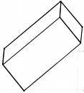](http://images.google.com/imgres?imgurl=http://ngfl.northumberland.gov.uk/clipart/Shapes/images/cuboid3_jpg.jpg&imgrefurl=http://ngfl.northumberland.gov.uk/clipart/Shapes/pages/cuboid3_jpg.htm&usg=__qH57wksoodqZqOxY8J97GWmrv78=&h=482&w=439&sz=16&hl=en&start=19&tbnid=AZqGGqPPdspThM:&tbnh=129&tbnw=117&prev=/images?q=cuboid&gbv=2&ndsp=18&hl=en&sa=N&start=18)S = 2x2 + 4()

x

y

**Surface Area of a Cube:**

S = 6($s^{2}$)

s

s

**Surface Area of a Right Square Pyramid:**

S = s2 + 4[ s l] **or** S = s2 + 2(s l)

[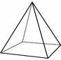](http://images.google.com/imgres?imgurl=http://www.doitpoms.ac.uk/tlplib/atomic-scale-structure/images/square_pyramid.gif&imgrefurl=http://www.doitpoms.ac.uk/tlplib/atomic-scale-structure/single1.php&usg=__ct-Zl9GIpK-Vsc7dr8ByDJ-Rv78=&h=113&w=116&sz=3&hl=en&start=2&um=1&tbnid=MhQPxN2Vmfp4vM:&tbnh=85&tbnw=87&prev=/images?q=square+based+pyramid&hl=en&rlz=1T4DKUS_enUS288US288&sa=N&um=1)

l

s

s

**Surface Area of a Right Circular Cylinder:**

S = 2(${πr}^{2}$) + (2 $π$ rh)

r

h

**Surface Area of a Right Triangular Prism:**

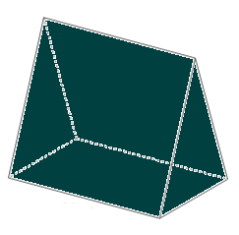S = 3(l $∙$ b) + 2( $\frac{1}{2}∙$ b $∙$ h)

h

l

b

This innovating project will be fun for students!! The City Skyline project is a great way to incorporate surface area and nets into a lesson. Students will learn how to make nets, which they can then use to create buildings, ultimately creating an entire city. Throughout this particular project students will be creating a city skyline of Buffalo, NY. They will be using well-known buildings throughout the city such as Buffalo City Hall, HSBC Tower, Statler Towers and many more. To create each building the students will use their knowledge of net making, and along with given dimensions they will be asked to find the surface area of each building. The students will then be broken into groups and each group will be in charge of one building to assemble. After constructing each building students will then put all the buildings together on a table top display. This project can also be used for more than just finding surface area, such as, when teaching volume, parallel and perpendicular lines (from the roads).The man idea of this project is for students to use their imaginations and have fun, let’s get started!!!

**What is a net?**

* A net is a flattened out version of a figure that shows each face of the figure and can be “folded up” so that a 3-d figure is created.
* When making a net for a 3-d figure, each face must touch another face along at least one edge, and all of the vertices must match up.

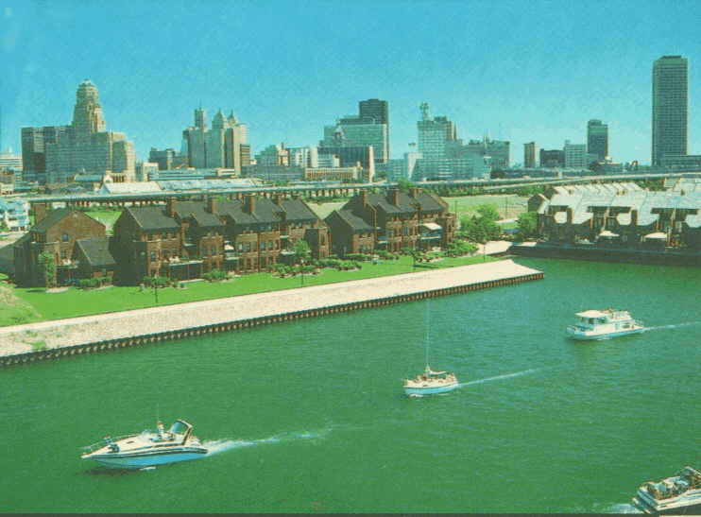

**Materials:**

* Construction Paper/Foam Board
* Pencils/Markers
* Graph Paper
* Glue/Tape
* Scissors
* Rulers

**How to Construct:**

* Using the dimensions below and graph paper create a net of each geometrical figure.
* Cut your nets out from your graph paper.
* Trace your figures onto construction paper.
* Cut your construction paper out to obtain a complete net.
* Fold and tape the nets into the desired figures.
* Once each figure has been completed, use the picture of the building as a reference and attach the figures to create the finished building.
* Repeat this process for every building.

**Building Dimensions**

Construct each part of the buildings according to the dimensions then use the picture as a reference to put all your nets together.

* The following dimensions represent each building to scale.
* The height, width, and length are all in terms of blocks (or units) on graph paper.
* Each block on graph paper represents 10 feet.

**HSBC Tower/Center**

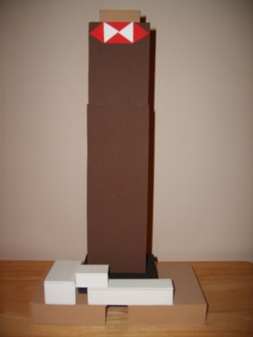

|  |  |  |  |  |
| --- | --- | --- | --- | --- |
| **Quantity** | **Shapes** | **Height** | **Width** | **Length** |
| 1 | Rectangular Prism | 52 | 6 | 12 |
| 1 | Rectangular Prism | 3 | 4 | 8 |
| 2 | Rectangular Prism | 4 | 15 | 19 |
| 1 | Rectangular Prism | 4 | 4 | 16 |
| 1 | Rectangular Prism | 5 | 6 | 9 |
| 1 | Rectangular Prism | 3 | 4 | 6 |
|  |  |  |  |  |
|  | **Buffalo City Hall** |  |  |  |
|  |  |  |  |  |
| **Quantity** | **Shapes** | **Height** | **Width** | **Length** |
| 1 | Rectangular Prism | 6 | 18 | F:\DCIM\100SSCAM\SD531340.JPG30 |
| 2 | Cubes | 6 | 6 | 6 |
| 4 | Right Triangular Prism | 6 | 6 | 6 |
| 2 | Rectangular Prism | 26 | 5 | 18 |
| 2 | Rectangular Prism | 33 | 5 | 18 |
| 1 | Rectangular Prism | 40 | 8 | 18 |
| 1 | Cube | 4 | 4 | 4 |
| 1 | Cube | 2 | 2 | 2 |
|  |  |  |  |  |
|  | **Statler Towers** |  |  |  |
|  |  |  |  | F:\DCIM\100SSCAM\SD531336.JPG |
| **Quantity** | **Shapes** | **Height** | **Width** | **Length** |
| 1 | Rectangular Prism | 3 | 19 | 8 |
| 1 | Rectangular Prism | 3 | 6 | 14 |
| 1 | Right Triangular Prism | 3 | 13 | 14 |
| 3 | Rectangular Prism | 23 | 4 | 7 |
| 1 | Rectangular Prism | 17 | 4 | 23 |
|  |  |  |  |  |
|  | **Adam’s Mark Hotel** |  |  |  |
|  |  |  |  | F:\DCIM\100SSCAM\SD531330.JPG |
| **Quantity** | **Shapes** | **Height** | **Width** | **Length** |
| 1 | Rectangular Prism | 14 | 6 | 28 |
| 1 | Rectangular Prism | 6 | 6 | 18 |
| 1 | Rectangular Prism | 6 | 6 | 28 |
| 1 | Rectangular Prism | 6 | 8 | 16 |
| 1 | Right Triangular Prism | 6 | 6 | 6 |
| 1 | Rectangular Prism | 6 | 6 | 10 |
|  |  |  |  |  |
|  | **HSBC Atrium** |  |  | F:\DCIM\100SSCAM\SD531325.JPG |
|  |  |  |  |  |
| **Quantity** | **Shapes** | **Height** | **Width** | **Length** |
| 1 | Rectangular Prism | 13 | 9 | 26 |
| 4 | Rectangular Prism | 4 | 4 | 34 |
| 4 | Rectangular Prism | 10 | 12 | 10 |
| 2 | Rectangular Prism | 6 | 10 | 6 |
| 2 | Rectangular Prism | 3 | 8 | 20 |

**Can you be creative?**

Use your imagination and create the HSBC Arena, Coca-Cola Field and the McKinley Monument in Niagara Square.

How would you make trees, the skyway and Lake Erie?

Use the picture below for ideas…

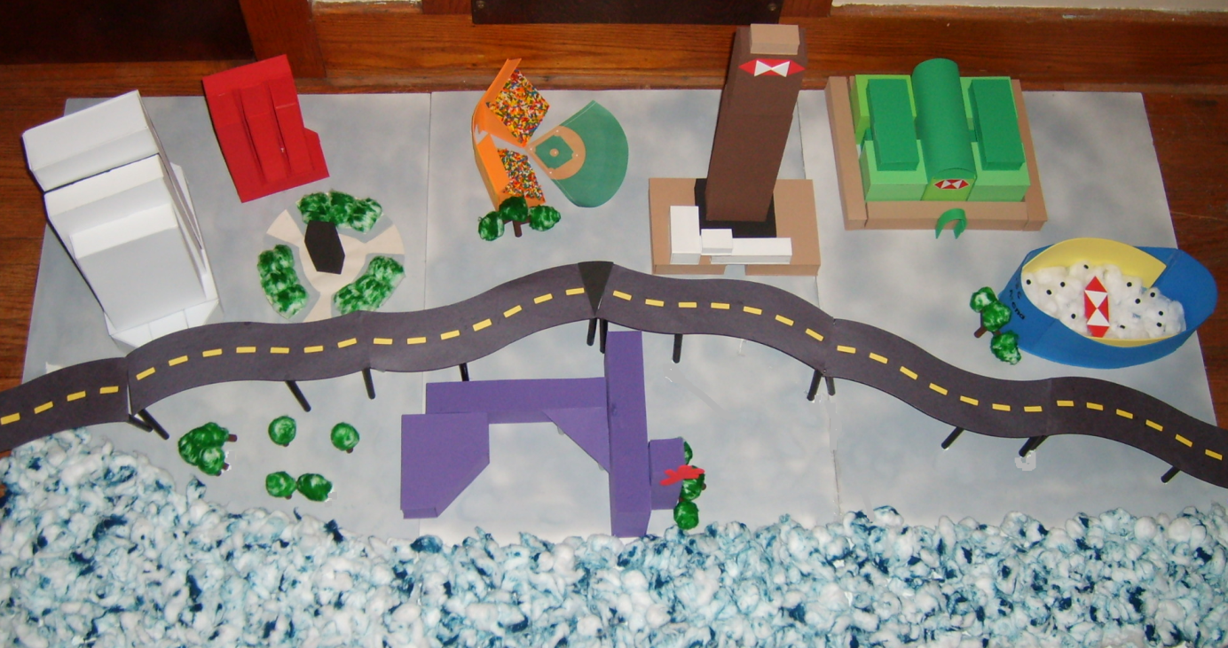

Here is a quick and fun one-day activity you can do with your students in your classroom!

Fun facts about the **Empire State Building:**

* The Empire State Building was built in 1931,
* The Empire State Building is the 3rd tallest building in the United States and 10th tallest in the World.
* The Empire State Building has over 100 floors and is more than 1,250 feet tall.

**Materials:**

* Construction Paper/Foam Board
* Pencils/Markers
* Graph Paper
* Glue/Tape
* Scissors
* Rulers

**How to Construct:**

* Using the dimensions below and graph paper create a net of each geometrical figure.
* Cut your nets out from your graph paper.
* Trace your figures onto construction paper.
* Cut your construction paper out to obtain a complete net.
* Fold and tape the nets into the desired figures.
* Once each figure has been completed, use the picture of the building as a reference and attach the figures to create the finished building.

How would you create the top of the Empire State Building?

**\*Dimensions are attached**

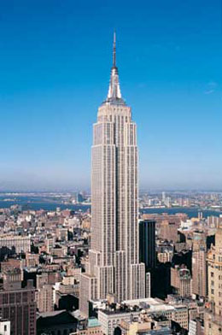

 Empire State

 Building Nets





4

45 x 35 blocks

4





35 x 25



35 x 25



Here is a quick and fun one-day activity you can do with your students in your classroom!

Fun facts about the **Kodak Building:**

* The Eastman Kodak Building was built in 1914.
* The Eastman Kodak building stands 360 feet tall with 16 floors.
* When it was first built it was the tallest building in Rochester now it is the 4th tallest in Rochester.
* This building now serves as Eastman Kodak’s World Headquarters.

**Materials:**

* Construction Paper/Foam Board
* Pencils/Markers
* Graph Paper
* Glue/Tape
* Scissors
* Rulers

**How to Construct:**

* Using the dimensions below and graph paper create a net of each geometrical figure.
* Cut your nets out from your graph paper.
* Trace your figures onto construction paper.
* Cut your construction paper out to obtain a complete net.
* Fold and tape the nets into the desired figures.
* Once each figure has been completed, use the picture of the building as a reference and attach the figures to create the finished building.

**\*Dimensions are attached**

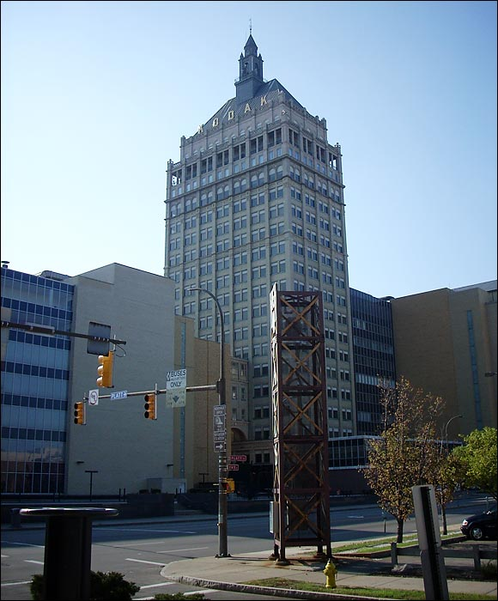

**Kodak Building**

**Nets**



36 x 11

22 x 36

22 x 36

36 x 11



9 x9 blocks



9 x 9 blocks

Here is a quick and fun one-day activity you can do with your students in your classroom!

Fun facts about the **United Nations Building:**

* Located in New York City, the United Nations Building has been the headquarters for the UN since 1949.
* The United Nations Building has 39 floors and is 510 feet tall.

**Materials:**

* Construction Paper/Foam Board
* Pencils/Markers
* Graph Paper
* Glue/Tape
* Scissors
* Rulers

**How to Construct:**

* Using the dimensions below and graph paper create a net of each geometrical figure.
* Cut your nets out from your graph paper.
* Trace your figures onto construction paper.
* Cut your construction paper out to obtain a complete net.
* Fold and tape the nets into the desirable figures.
* Once each figure has been completed, use the picture of the building as a reference and attach the figures to create the finished building.

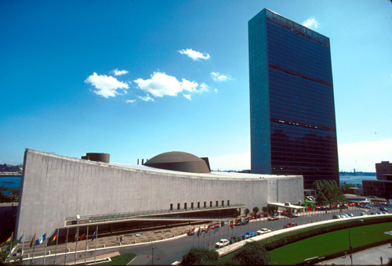**\*Dimensions are attached**

United Nations Building



34 x 9 blocks

11 x 34 blocks

2 x 11 blocks

2 x 11 blocks

44 x 22 blocks

44 x 22 blocks

**Feeling creative?** You can add a box for the flags. The flags shown in the picture were printed off line, glued to toothpicks and stuck on the box.

The boxes dimensions are 21 x 2 x 3.