SUNY Fredonia Jennifer Carmello – carm0135@fredonia.edu
AMTNYS 2009 Jackie Majka – majk0773@fredonia.edu Ashley Martin - mart6740@fredonia.edu

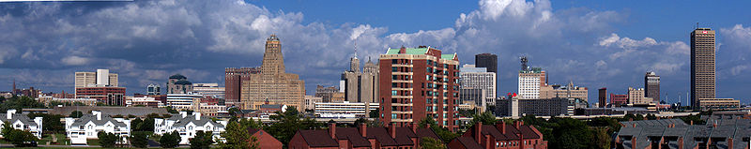

Introduction:
This innovating project will be fun for students!! The City Skyline project is a great way to incorporate surface area and nets into a lesson. Students will learn how to make nets, which they can then use to create buildings, ultimately creating an entire city. Throughout this particular project students will be creating a city skyline of Buffalo, NY. To create each building the students will use their knowledge of net making, and along with given dimensions they will be asked to find the surface area of each building. This project can also be used for more than just finding surface area, such as, when teaching volume, parallel and perpendicular lines (from the roads).The man idea of this project is for students to use their imaginations and have fun! This project can be used at the middle school or high school level as an interdisciplinary lesson.

Relevant Professional Standards:
NCTM Standards:
- Use representations to model and interpret physical, social, and mathematical phenomena.
- Understand how mathematical ideas interconnect and build on one another to produce a coherent whole.
- Recognize and apply mathematics in contexts outside of mathematics.
- Recognize and apply geometric ideas and relationships in areas outside the mathematics classroom, such as art, science, and everyday life.
- Use geometric models to represent and explain numerical and algebraic relationships.

NYS-MST Standards:
- 8.R.4: Explain how different representations express the same relationship
- G.PS.3: Use multiple representations to represent and explain problem situations (e.g. spatial, geometric, verbal, numeric, algebraic, and graphical representations)
- G.RP.2: Recognize and verify, where appropriate, geometric relationships of perpendicularity, parallelism, congruence, and similarity, using algebraic strategies
- G.G.12-16: Apply the properties of a regular pyramid, a cylinder, a prism, a right circular cone, and a sphere including surface area, volume, and using the area formulas to determine surface area.

Major Instructional Objectives:
Following the completion of this lesson students, should be able to:
- Calculate proportions given the actual dimensions of the buildings.
- Create scaled models of the buildings.
- Calculate surface area given the dimensions of buildings located in New York State.

Instructional Protocol/Itinerary:
- This lesson can be broken apart into three one day activities in which students create a scaled model of the Empire State Building in New York City, the United Nations Building in New York City, or the Kodak Building in Rochester.
- As an assignment during a geometry unit, the Buffalo City Skylines project can be used to teach students proportions, surface area, volume, and parallel and perpendicular lines.

